Physical RAID Scenario 1
Customer requirements 1
Screenshot 1 1
NAS component 2
Screenshot 2 4
SAN Portion 5
Requirements 5
Supporting information 5
Screenshot 3 6
Wireshark 7
DoH (DNS over HTTP 7
Screenshot 4 8
IPv6 8
Screenshot 5 9

Physical RAID Scenario
Using the Intel RAID controller simulator solve the following customer's problem

A customer has purchased a SAN and has hired you to configure their SAN.

Customer requirements
The customer purchased a SAN to provide access to their database, which currently has been running on a single server. They plan to distribute the load across 4 database servers, 3 read-only and 1 with write access to the database.

1) The customer requires redundancy in case of a drive failure
2) The drive must rebuild automatically without interrupting IT. IT will replace this spare during business hours regardless of time of failure.
3) The database must not suffer from write penalties
4) How can we balance redundancy and maximum performance?

Screenshot 1
Name your volume: FirstName-challenge (shorten as needed to make it fit)
You can use all available disks to make a single volume group to solve the customer’s problem.
A single screenshot showing your solution with the volume group clearly visible.
Single sentence as to WHY this is the best solution.

NAS component
Requirement: TrueNAS
Hostname: Lastname-NAS (you may reuse an existing TrueNAS install, if there is an issue you might have to rebuild.)

NOTE: This operation is destructive. Snapshot do not work in this scenario, you’ll need to make full clones if you don’t want to reinstall TrueNAS.

Using any RAID type of your choice
1) Build the RAID array, using the disks chosen.
2) Include a hot spare in your group

Remember we used a combination of unique drive sizes and descriptive names for the disk such as Disk 5.vmdk to make identification easier.
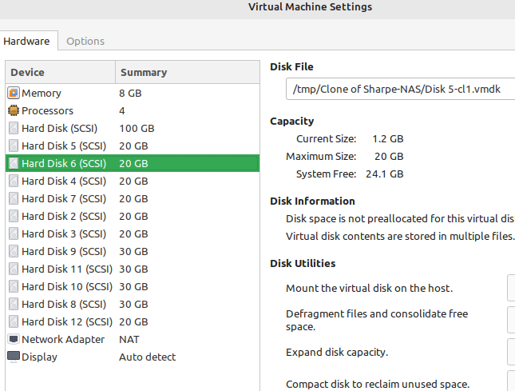

Your task!
With your raid array (pool) in good health and a spare I want you to remove a drive. You’ll have to shutdown the server for this.

Note: Don’t accidentally remove your hot spare. Doing so will not trigger a rebuild

At this point your pool should be degraded. A key point here is that FreeBSD’s hot spare isn’t automatic. Linux is, FreeBSD no. There is a reason TrueNAS is moving to Linux.

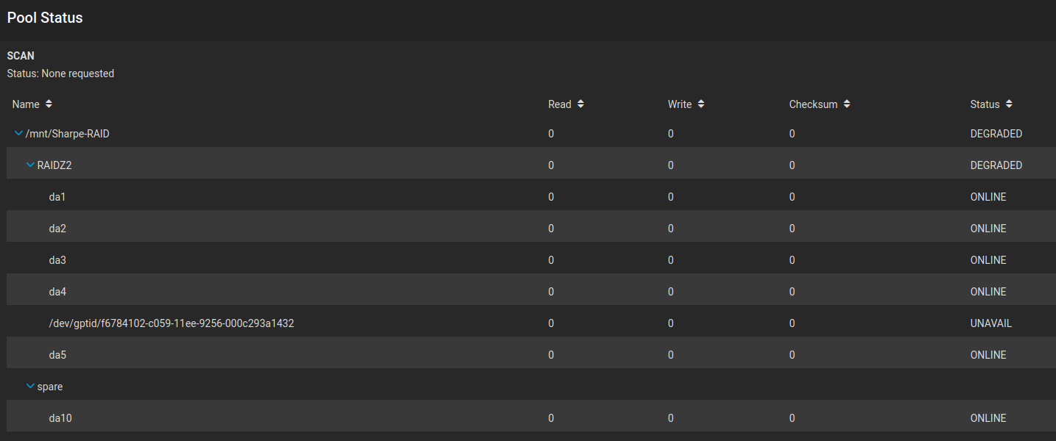
You have to mark the failed drive as OFFLINE using the three dots on the far right side of the drive’s row.
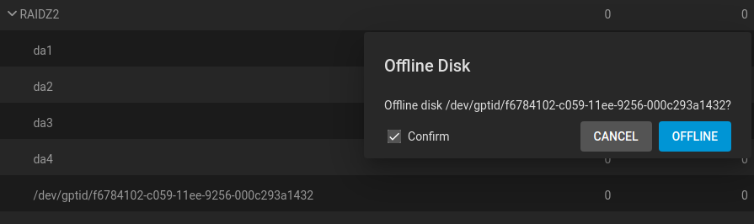

Then this is the weird part. You have to actually remove your hot spare to to see the hot spare during the replace operation. Select to remove the hot spare. Hit refresh on your browser.
You’ll now have the option to replace with that drive.
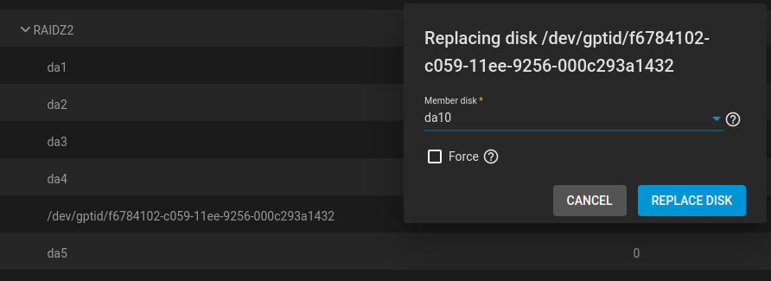

Screenshot 2
Include all three highlighted portions. Hostname must be Lastname-NAS. Screenshot should show the drive being replaced and rebuilt.
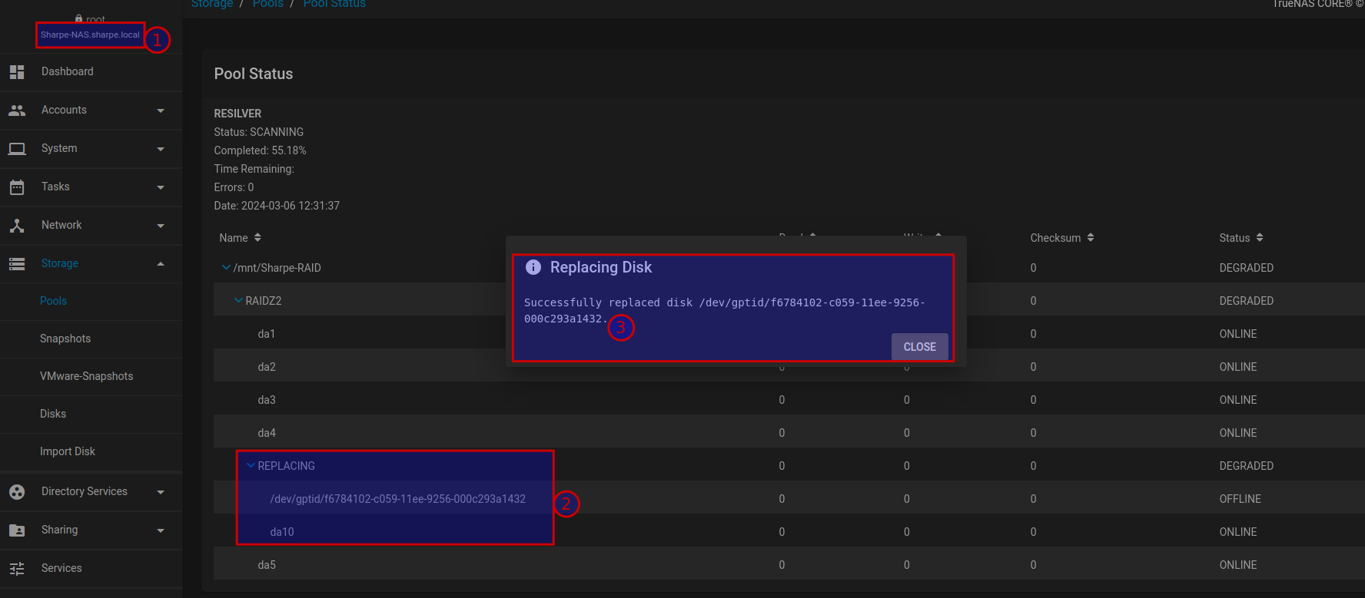
Once you hit refresh everything should be right as rain and healthy.

SAN Portion

Requirements
IQN: must include FirstName-challenge-target
Drive size: 42GB
Drive volume label: best-challenge-ever

The drive is to be mounted on Windows Server, any version.

Supporting information
Refresh your knowledge on how iSCSI addressing works
A few resources: VMware’s documentation or Wikipedia on addressing.

For the target you may use either your existing knowledge on configuring iSCSI targets in Windows Server or you may use TrueNAS which does support the iSCSI target service.

Hint. When creating an iSCSI target in Windows, go slow and look for where you set the target name.
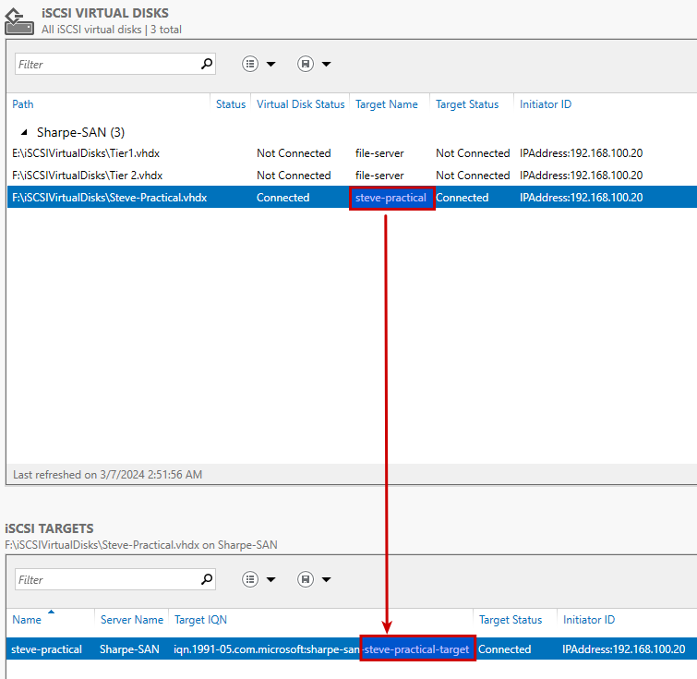

Screenshot 3

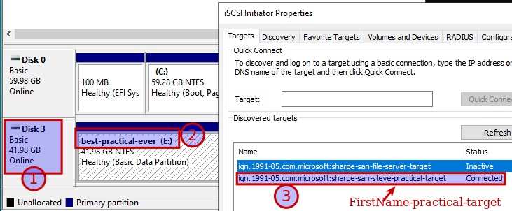
1) The drive is 42GB (41.98 rounds to 42GB)
2) Volume label is best-challenge-ever
3) The IQN has been modified to include FirstName-challenge-target
All or nothing. 1 through 3 must be visible and correct. Single screenshot, arrange windows as shown.

Wireshark

For this portion you’ll be looking at two emerging technologies using skills learned through Wireshark.

Requirements:
Wireshark
Cloudflare VPN client

DoH (DNS over HTTP
Research DNS over HTTP
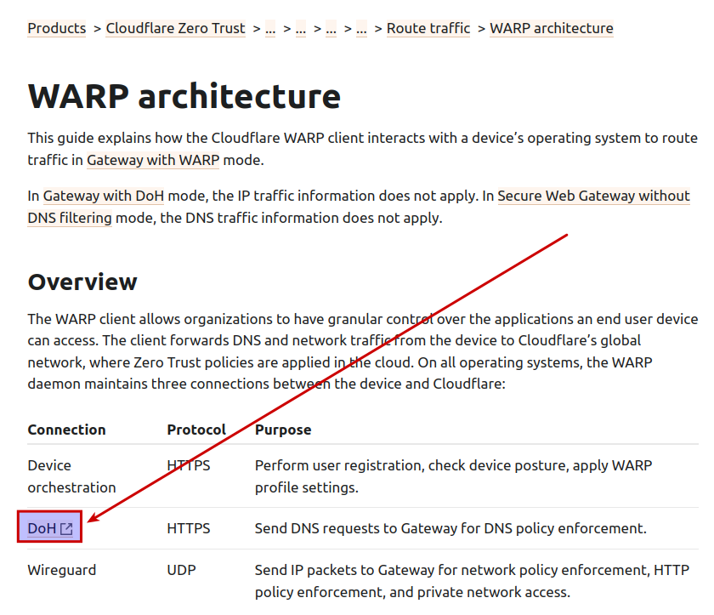

Screenshot 4
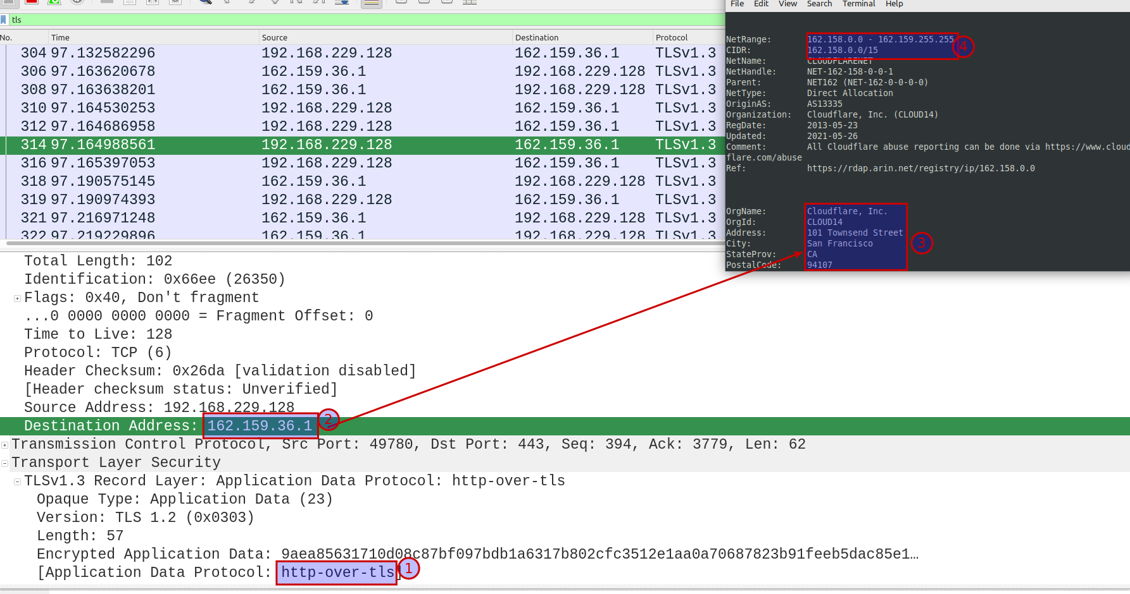
1) identifying the application traffic as http-over-tls this may only show as only 443 (tls) that's fine
2) destination IP
3) registration proving this is owned by Cloudflare
4) within the range 162.159.36.1 to 162.159.46.1 This is an absolute requirement.
All four points visible plus your computer name visible.
Using the outside interface, which is the portion connected to the internet (eduroam or home wifi). Locate HTTP traffic with a destination address below. Show the application layer in Wireshark with the source and destination addresses visible.
IPv4 DoH Addresses: 162.159.36.1 and 162.159.46.1 Source: WARP with firewall

IPv6

IPv4 has been hanging around for a long time, but browsers have been defaulting to IPv6 when available. IPv6 has been an emerging technology for a very, very, very long time and is extremely important.

Screenshot 5
Using the inside address of your VPN locate an IPv6 connection. Any connection will do.
Use whois to verify that your address belongs to Cloudflare. To do this simply enter that address into whois and the registration will appear.

1) must show the source and destination IP address
2) the computer name that must be personalized with your name
3) arrange the windows to show the output from whois showing your source IP address belongs to Cloudflare.

